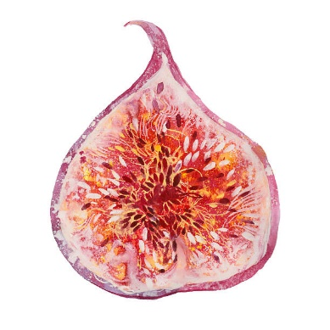
FIRST-YEAR INTEREST GROUP (FIG)
PROPOSAL FORM - FALL 2018
The deadline for submitting proposals is February 5, 2018.

Please complete this form, including all signatures, and submit to the FIG Program. Include the syllabus for each of the two academic courses, if the FIG is new. *If you want to change a previously offered FIG, please include the syllabus for the new course.

Title of FIG:  Department:  Phone Number:  Course #1  Course Title:  Sponsoring Dept:  Subject Code/#:  Instructor Name:  Instructor Title | FIG Instructor:  Title(Prof/Adjunct/Instr):  Email:  Course #2  Course Title:  Sponsoring Dept:  Subject Code/#:  Instructor Name:  Instructor Title
Description of FIG
Please provide a one-sentence description of your FIG, which may be used in promotional materials:

Approvals

The signatures below or approval received via email confirm 1) the faculty proposing this FIG have the approval of the sponsoring departments offering the courses listed above, 2) the two proposed academic courses are regular parts of the departmental curricula, and meet general-education requirements, 3) the courses will be offered fall term 2018, and 4) the faculty members, exclusive of the proposed FIG, have/will have appointments in UO departments during the fall term 2018.

Course 1 Instructor: ____________________ Department Head: ____________________________

Course 2 Instructor: ____________________ Department Head: ____________________________

FIG Instructor: ____________________ ____ Department Head: __________________________
(Needed if FIG Instructor is different than Course 1 or Course 2 Instructor)

Please return this form to Jackie Etchison, FIG Program 1st floor Oregon Hall, or by email at jle@uoregon.edu
*If you are proposing a new FIG, please contact Amy Hughes Giard, Director of the FIG Program, to discuss your proposal – agiard@uoregon.edu or 541-346-1079

